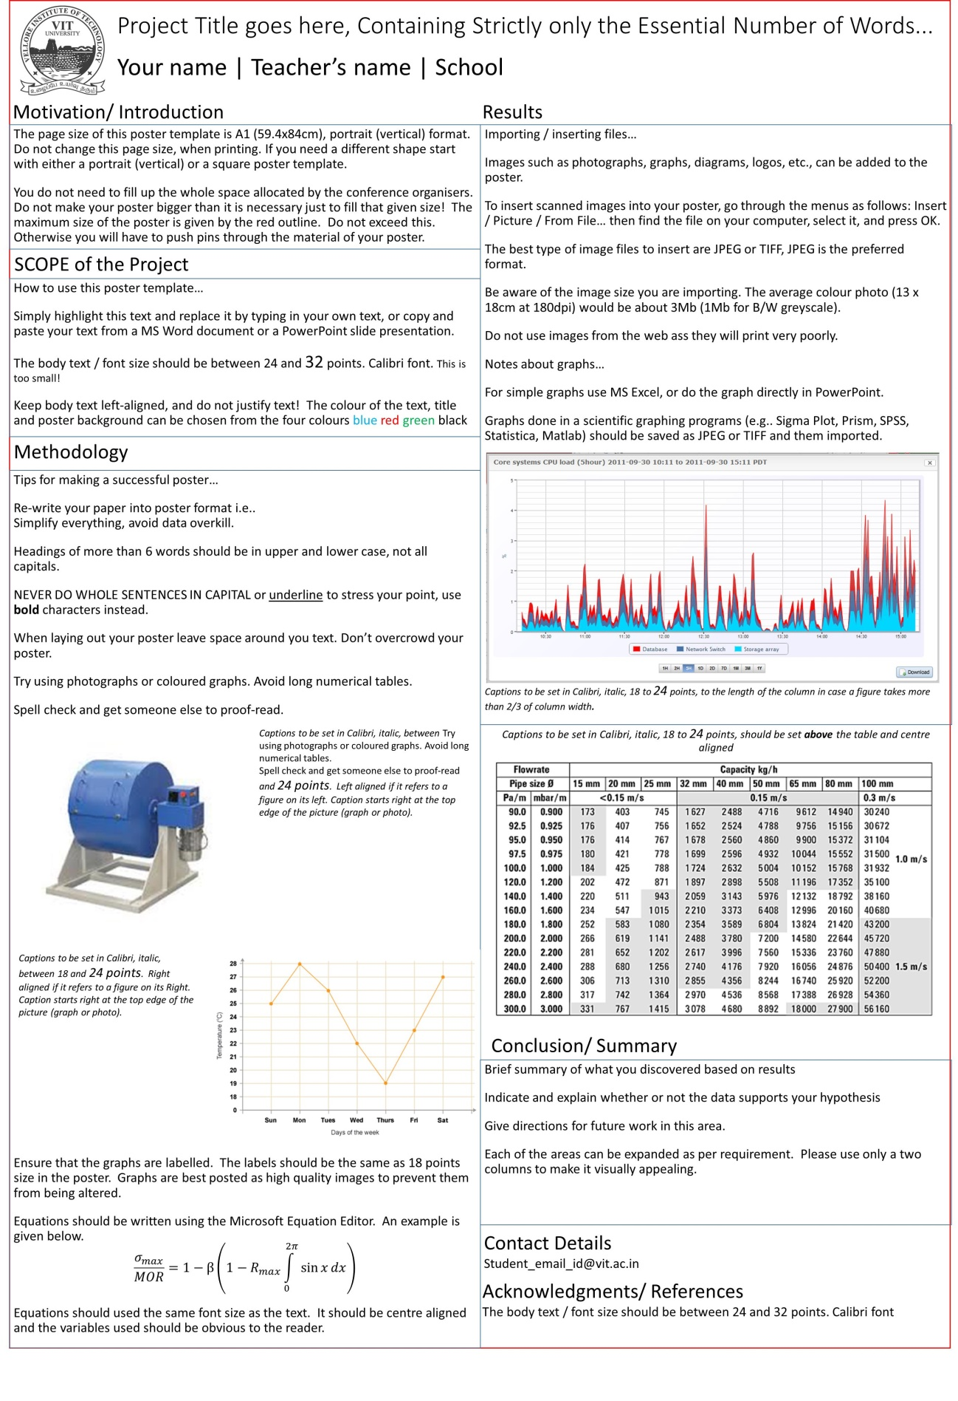
The intended target population is the students of the VIT University as well as professors who are willing to accept innovative projects. The aim of the report is to convince the stakeholders and draw the attention of the readers to the multifaceted utilities of the product being developed.

The project requires the help of mechanical and civil engineering students to get an insight into modelling software like Solid works and AUTOCAD.
BASIC STRUCTURE: The basic structure of the bucket is inverted frustum.
MATERIAL: Plastic is an appropriate material since it is easily washable. The thickness of the plastic is 3mm.
HEIGHT: The proposed height of the structure is 26 cm.
BASE: The base of the frustum has a radius of 7.5 cm. The base is circular. The radius of the cylinder attached to the base is 3.5 cm.
TOP: The top of the frustum has a radius of 13 cm.
DIVIDERS: The dividers are fixed and have been created at angles of 70 degrees, 70 degrees, 70 degrees and 150 degrees from the vertical. The dividers are attached to the inner cylinder at one end and outer cylinder at the other frustum.
BASE OFFSET: For three compartments, the base is 6.175 cm above the actual base of the frustum.
ANGLE OF FRUSTUM: The angle by which the frustum is slanted on the sides is 8.7692 radians.
PARTITION USAGE: The cylinder in the middle is used to store the soft drinks.
The single compartment which does not have an uplifted base is used for storing popcorns or alternatively whatever food item is supposed to be bought in large quantities.
The three compartments which have an uplifted base can be used for storing samosas, sandwiches, nachos, chicken lollipops, mobiles, bills and other personal stuff.
The product has the potential to be a major market influence due to its novelty along with the details that have been incorporated. The users are free to use the product in ways other than intended too.
“Snagger” shall be used at cinema halls for ergonomic placement and accessibility of food items to cater to the food needs of the audience by helping them to keep all their food stuff in a single tumbler.

TANAY HONEY DASH(15BCL1085), PRATEEK PATIL(15BME1245)
osho.agyeya2015@vit.ac.in
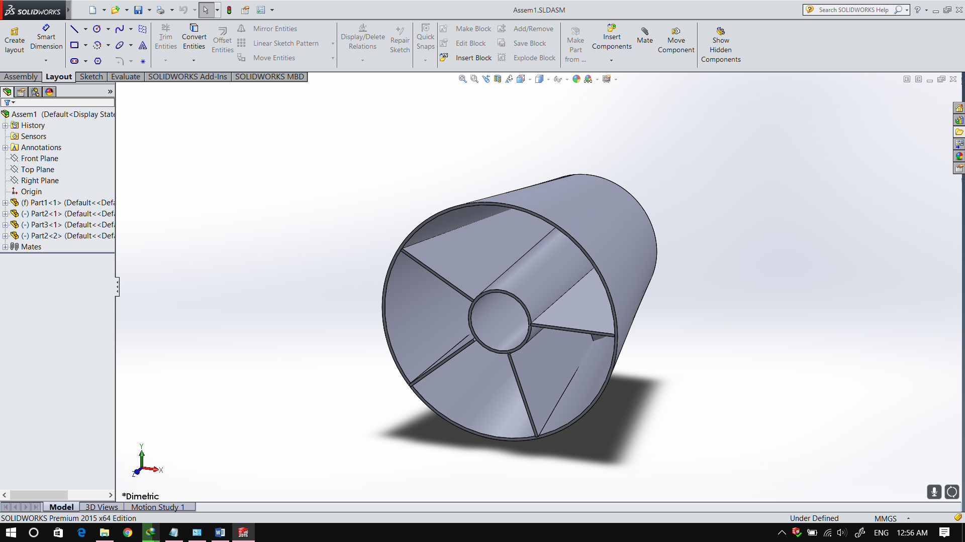

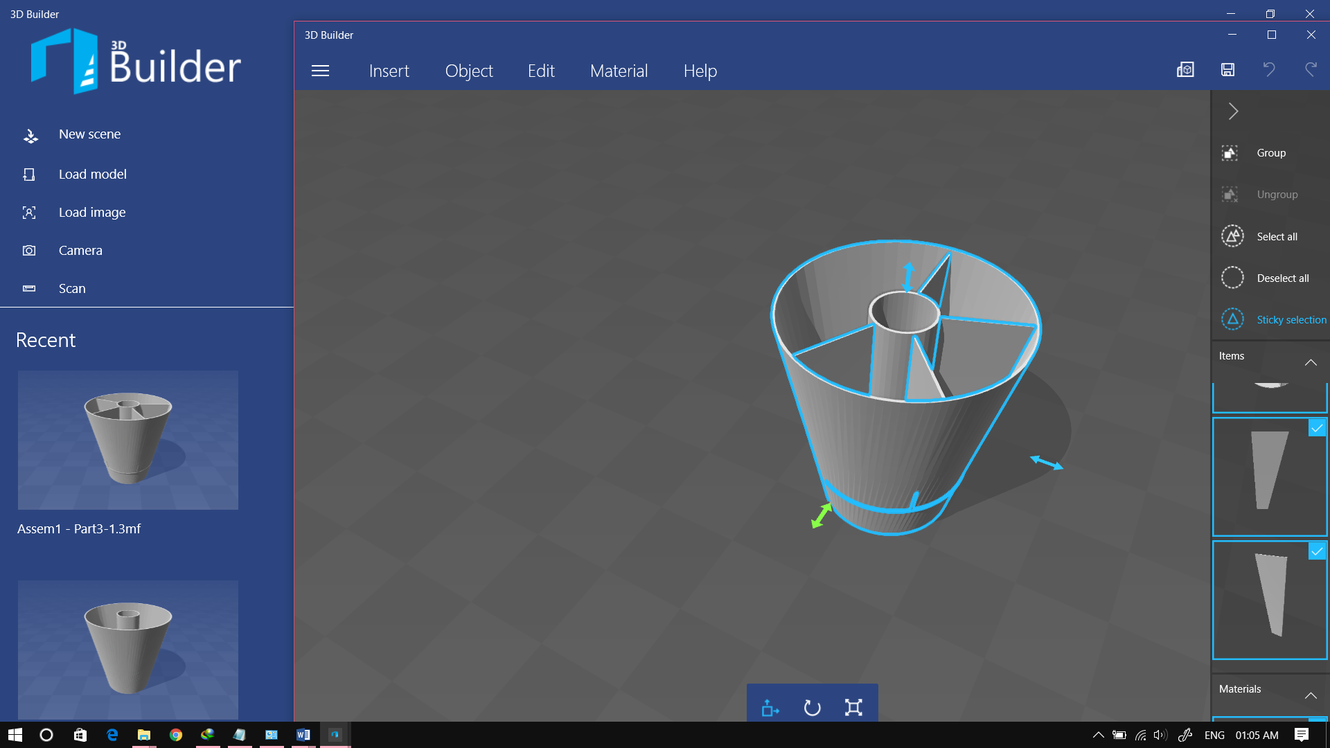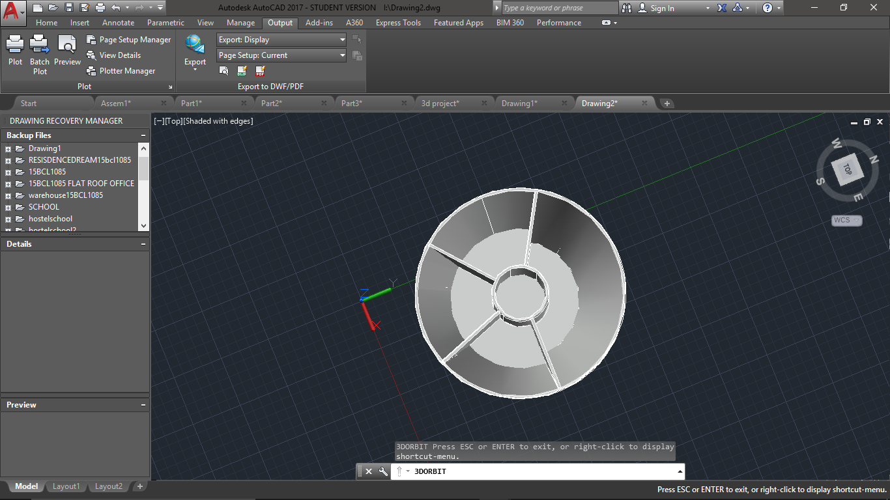
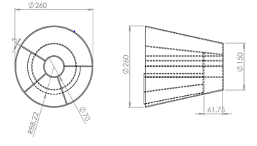
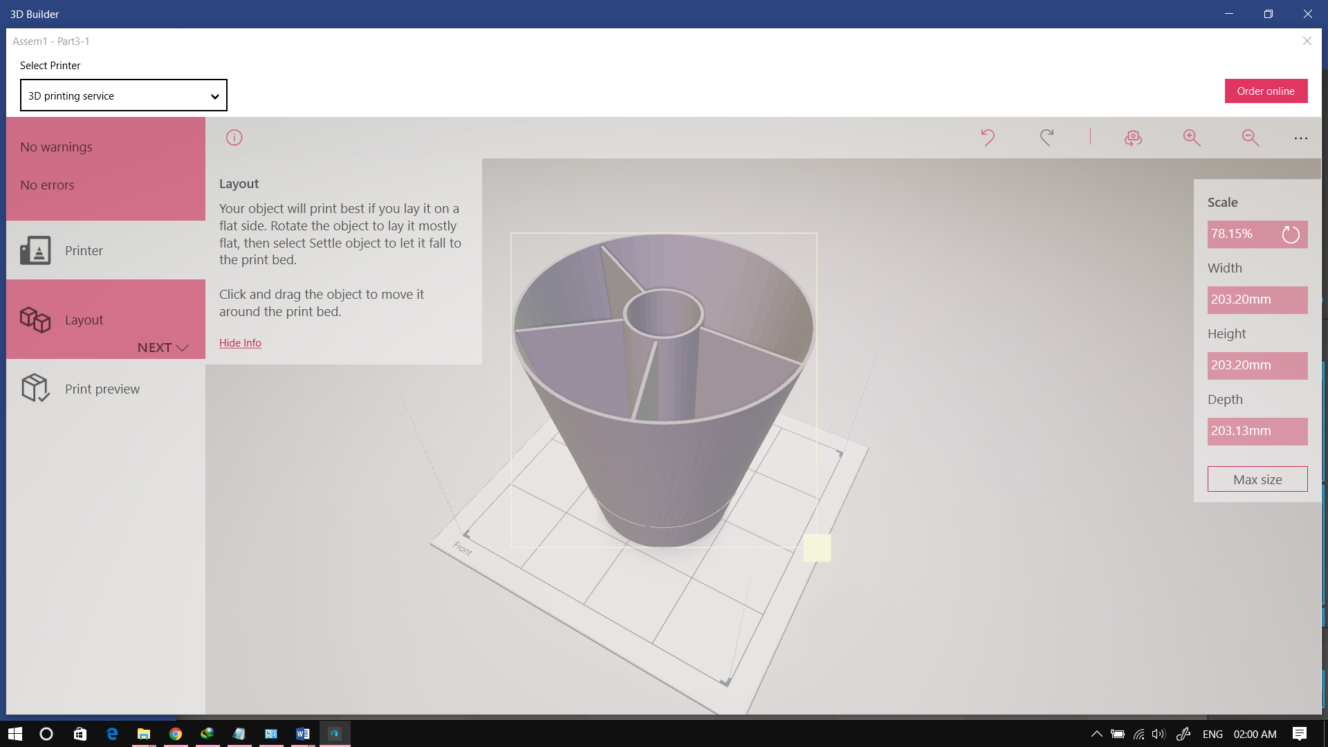
SNAGGER(SNACK WITH SWAGGER)
Osho Agyeya,Harshobhit Dayal,Shubham Parashar,Animesh Sen Gupta,Shriansh Srivastava|Balaji J|SCSE

